First Visit package - IVF

City Apartment House *** - in the hear of the city

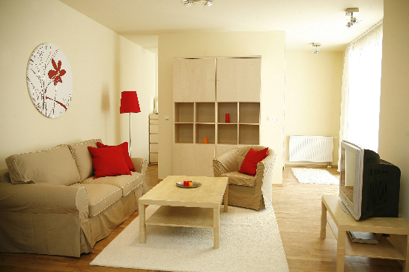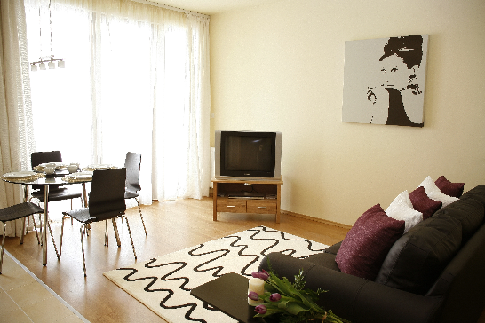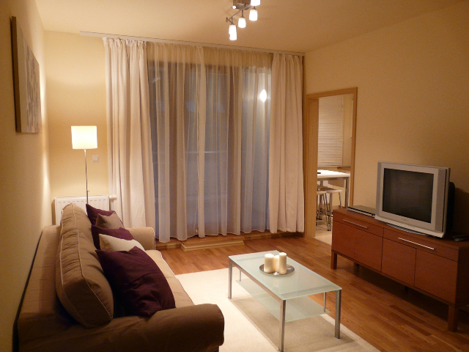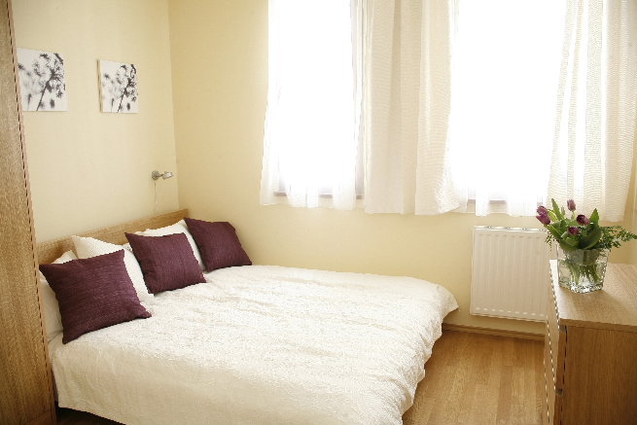

Accommodation:

City Apartments **** - in the Center of Budapest
Modern, fully equipped apartments with american style kitchen. The apartment house is located in the heart of Budapest downtown, just few minute walk from Budapest famous walking street and the most popular and visited places of the historical downtown

Price: 290 EUR - for You and Your Partner

What is included in the price?

- 1 night at City Apartments*** in the centre of Budapest for two person
- Personal consultation with the IVF specialist at our Fertility Clinic.
- Consultation include: review of any previous treatments, test results and medical records, detailed discussion with the fertility specialist, pelvic examination and ultrasound
- Complimentary airport transfers in private SCMT vehicles not a taxi or 3rd party
- We do not charge any extra for a partner to travel with you for transfers.
- All medical transfers including consultations, admission, discharges
- We undertake all hospital administration procedures to make it stress-free for YOU including, bookings for consultations, surgery dates etc...
- Free internet access in all the apartments
- We allocate you a Hungarian coordinator, who is going to be the person you see the most during your stay at Hungary. Her/his duties:
  - You can call her/him 24/7 if you need any kind of help
  - She/he can visit you in hospital and/or at your hotel to attend your consultations if you wish so, help you with your medications, collect your shopping and answer any further questions you may have.
- We provide you a Hungarian mobile phone, wit all the telephone numbers you might need stored in its memory and with some credit on it. This phone can be with you during your whole stay so it will be easy for YOU to contact us, call a taxi, book a restaurant or order pizza☺

How to start?

We organize everything for your first consultation before your IVF treatment

The only two things you need to do:

- Contact us and we arrange all booking for you - apartment booking and booking appointments at our Fertility Clinic
- Book your flight and buy your flight tickets and inform us about your exact arrival. Your personal assistant will wait for you at the Hungarian Aiport

