Gastric Balloon Package

Premium Apartment House ***+

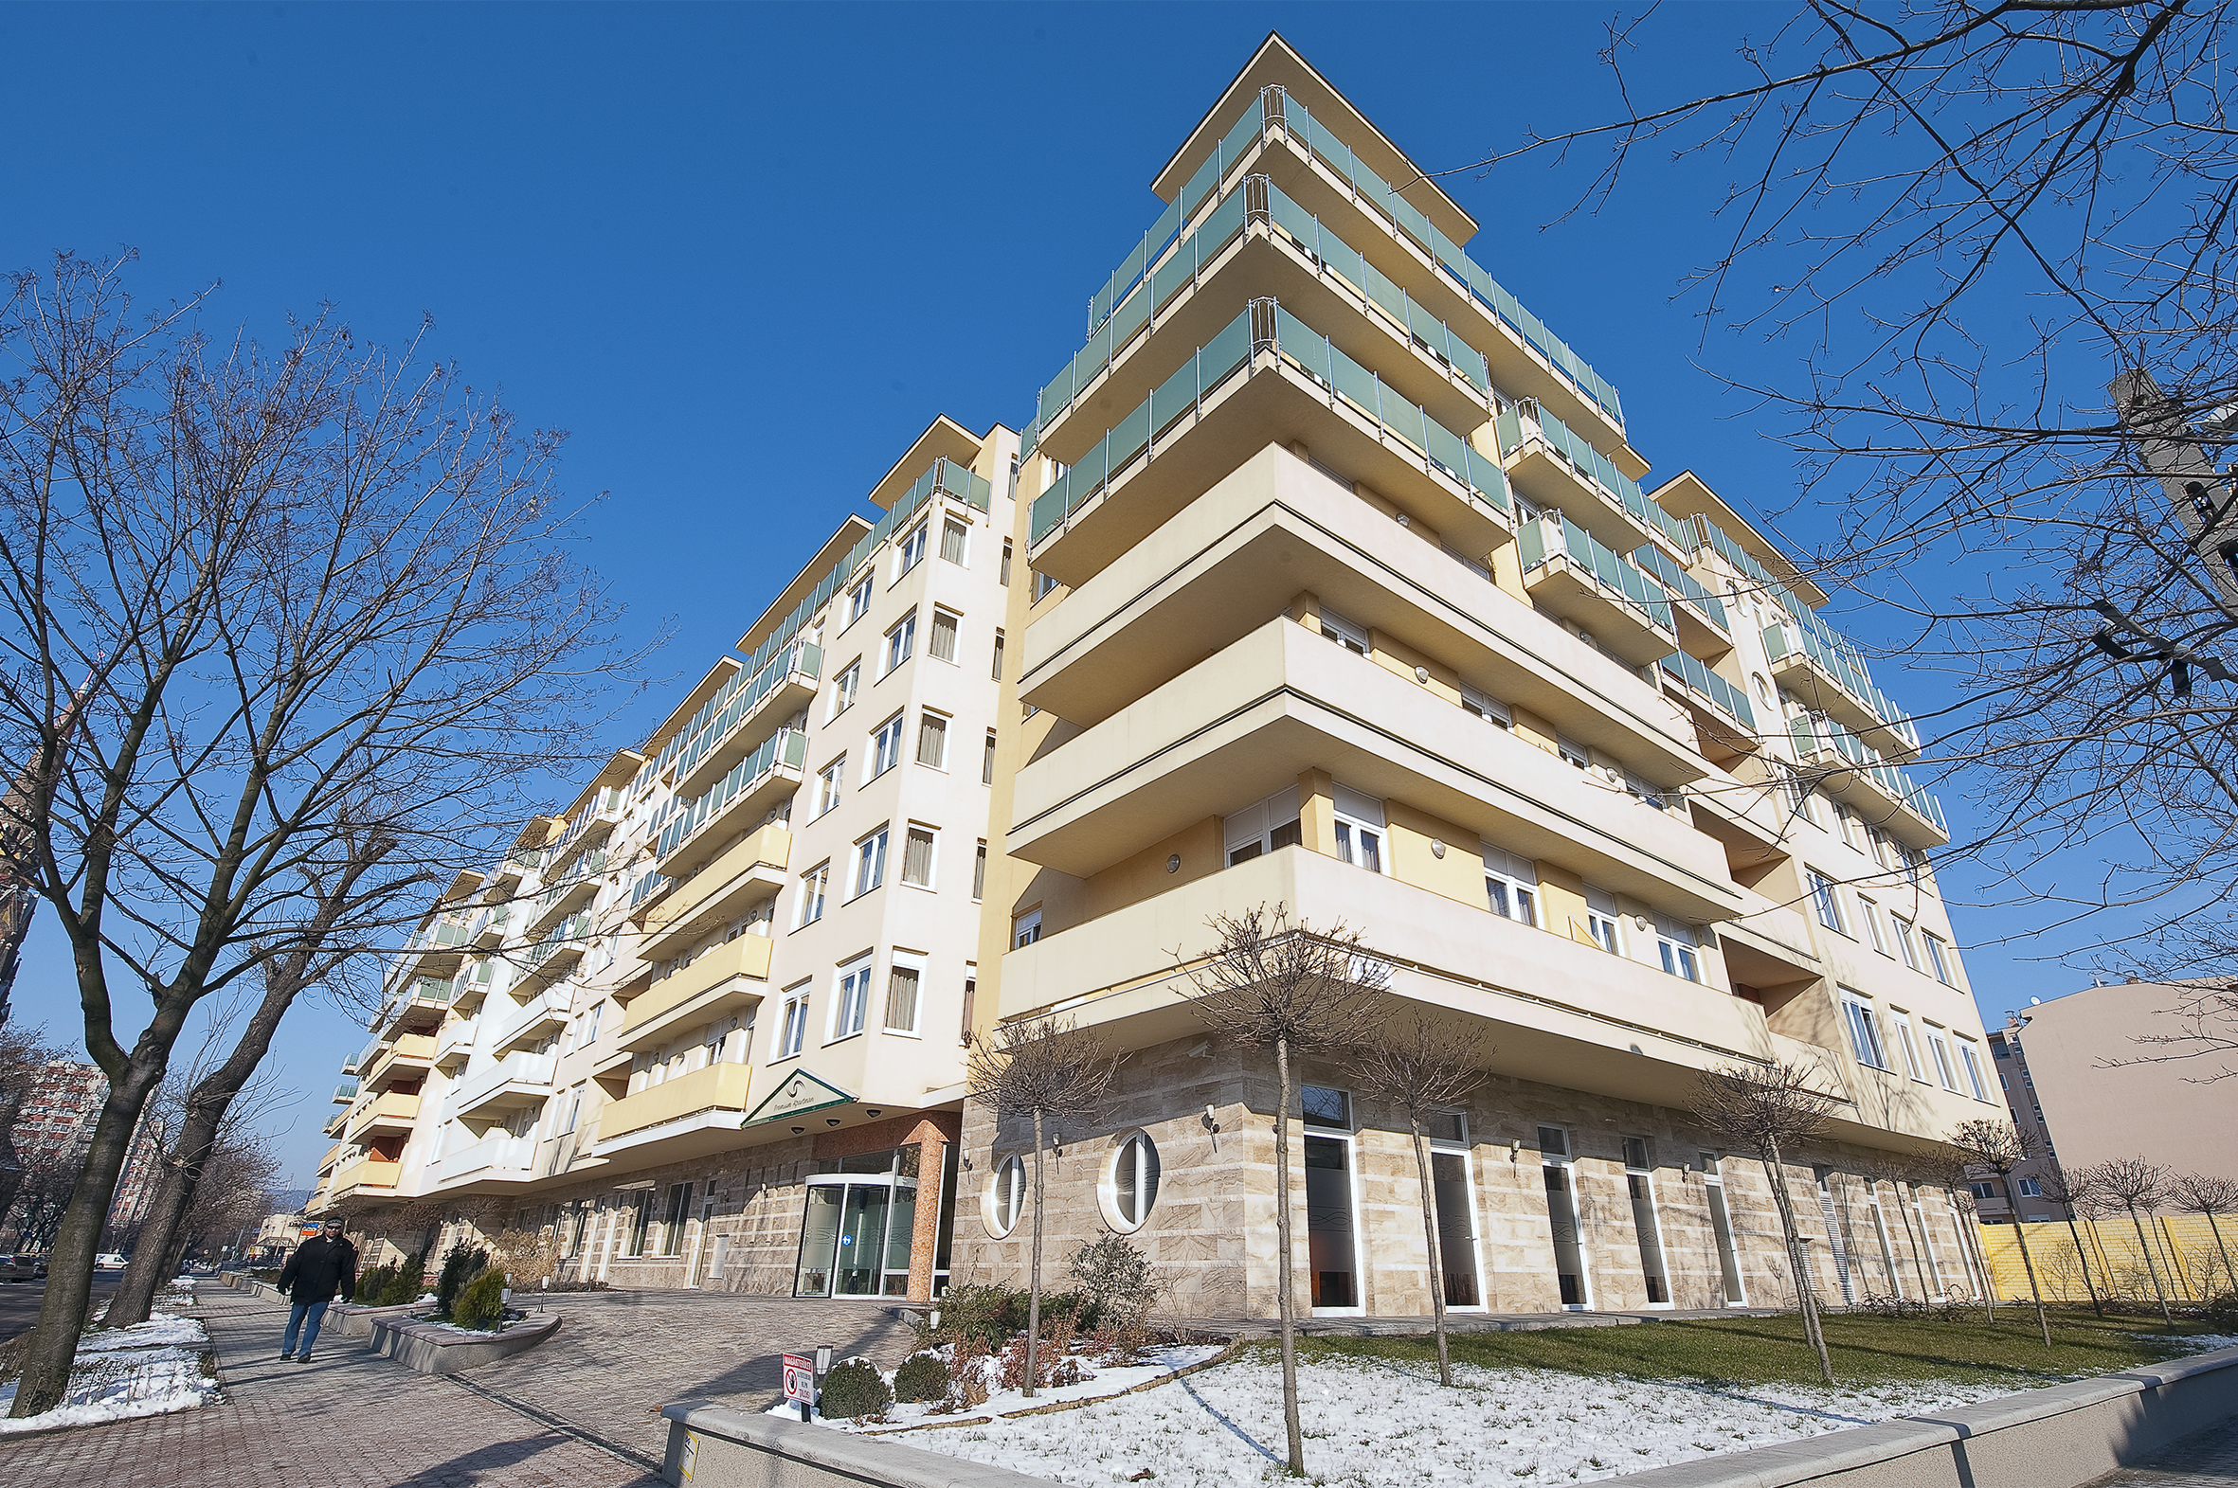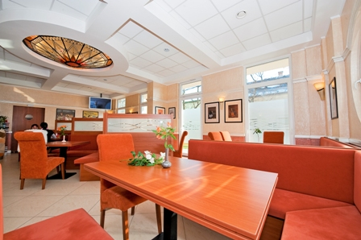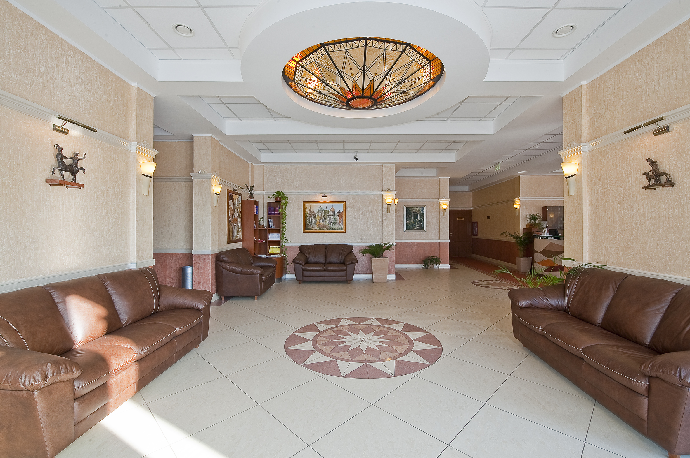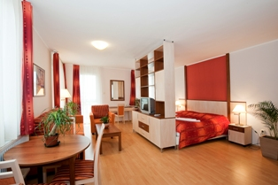

Accommodation at Premium Apartment House ***+ (comfortable and fully equipped, spacious apartments, with open style kitchen, 15 minutes from the City Centre by bus)

Price: 2750 GBP for You and Your Partner

The price includes:

- 3 + 2 night stay at Premium Apartment House ***+ for two people
- Gastric Ballon insertion performed by team of qualified gastroenteorologyst at our Partner Clinic
Including: Silimed Gastric Balloon insertion, local anaesthesia, one night accommodation at the Clinic according necessity, all medication you need to take after the balloon insertion
- Medically supervised aftercare program by a professional dietist
- Balloon extraction including 2 nights accommodation at Premium Apartment House
- 1 night stay at Gastric Balloon Clinic (if neccessary)
- Airport transfers in private SCMT vehicles not a taxi or 3rd party
- All medical transfers including consultations, admission, discharges
- All hospital administration procedures to make it stress-free for YOU including bookings for consultations, surgery dates, etc...
- We allocate you a Hungarian coordinator, who is going to be the person you see the most during your stay at Hungary. Her/his duties:
  - You can call her/him 24/7 if you need any kind of help
  - She/he can visit you in hospital and/or at your apartment to attend your consultations if you wish so, help you with your medications, etc..
- We provide you a Hungarian mobile phone, with all the telephone numbers you might need stored in its memory and with credit on it

Extra services, treatments –if needed- in addition: the costs of these additional services are not included
in package price

You can find more information about Gastric Balloon treatment on our website: www.scmedicaltravel.co.uk

How to start?

- Contact us (info@scmedicaltravel.co.uk) in order to get all information about your gastric balloon procedure and please fill out and send us back a medical questionery
- We book the Apartment for You and the appointment at our Partner Clinic
- Buy your flight ticket

