Gastric Balloon Package

City Apartment House ***+

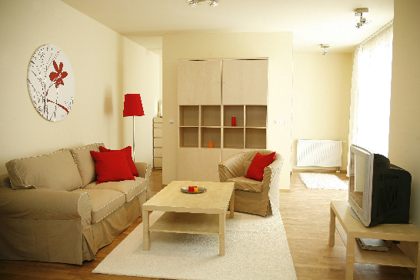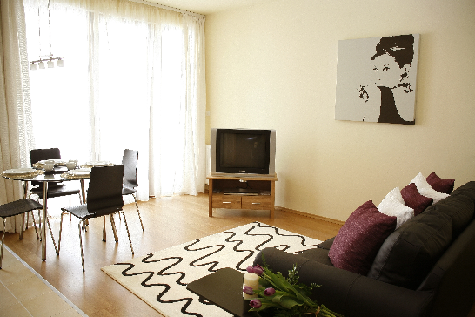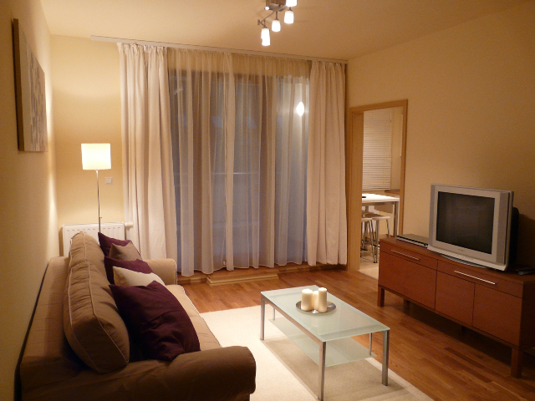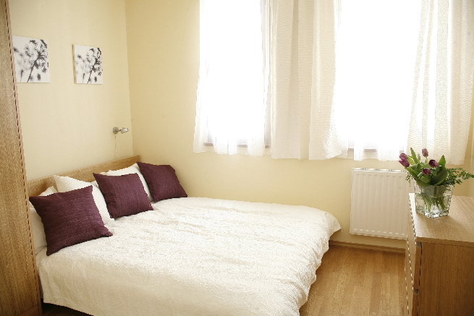

Accommodation at City Apartment House **** (modern, fully equipped apartments, with open style
kitchen. The apartment is located in the heart of Budapest downtown, just few minutes walk from Budapest famous walking street and the most popular and visited places of the historical downtown.

Price: 2850 EUR for You and Your Partner

The price includes:

- 3 + 2 night stay at City Apartment House ***+ for two person
- Gastric Ballon insertion performed by team of qualified gastroenteorologyst at our Partner Clinic
Including: Silimed Gastric Balloon insertion, local anaesthesia, one night accommodation at the Clinic according necessity, all medication you need to take after the balloon insertion
- Medically supervised aftercare program by a professional dietist
- Balloon extraction including 2 nights accommodation in City Apartment House
- 1 night stay at Gastric Balloon Clinic (if neccessary)
- Airport transfers in private SCMT vehicles not a taxi or 3rd party
- All medical transfers including consultations, admission, discharges
- We undertake all hospital administration procedures to make it stress-free for YOU including bookings for consultations, surgery dates, etc...
- We allocate you a Hungarian coordinator, who is going to be the person you see the most during your stay at Hungary. Her/his duties:
  - You can call her/him 24/7 if you need any kind of help
  - She/he can visit you in hospital and/or at your hotel to attend your consultations if you wish so, help you with your medications, collect your shopping and answer any further questions you may have.
- We provide you a Hungarian mobile phone, with all the telephone numbers you might need stored in its memory and with some credit on it. This phone can be with you during your whole stay so it will be easy for YOU to contact us, call a taxi, book a restaurant or order pizza☺

How to start?

- Please contact us (info@scmedicaltravel.co.uk) in order to receive all information about your gastric balloon procedure
- Fill out and send us back a medical questionery and inform us about your planned arrival
- Buy your flight ticket and inform us about your exact arrival. Your Hungarian coordinator will wait for you at the Budapest Airport

